**Optics, Vibrations and Waves**

**Physical Chemistry II Lab**

**CHM4111L**

**Dr. Clark**

#### **Objective and Relation to Lecture**

To explore the relationship between standing waves and quantum mechanical systems, demonstrating how boundary conditions lead to quantized states, as described by the Schrödinger equation.

#### **Introduction / Theory**

Standing waves are an excellent classical analog for quantum systems. The fixed boundaries of a vibrating string create discrete wave patterns (harmonics), similar to how boundary conditions in quantum systems result in quantized energy levels. In a standing wave, nodes are points where the displacement is always zero due to destructive interference. Antinodes are points of maximum displacement due to constructive interference. The number of nodes increases with the harmonic mode ($n$) of the standing wave.

In quantum mechanics, the behavior of particles (e.g. electrons) is governed by wave equations. These systems exhibit quantization, meaning that only specific energy levels are allowed, analogous to the discrete harmonic modes of a standing wave where the length of the string dictates allowed wavelengths. In quantum systems, the wave function ($ψ$) describes the probability amplitude of a particle’s position and momentum. Nodes in the wavefunction correspond to regions where the probability density (∣∣*2*) of the particle is zero.

Each quantum state is associated with a specific energy level, just as each harmonic mode of a standing wave corresponds to a specific frequency and wavelength. Just as a vibration string fixed at both ends has discrete modes of vibration ($n=1, 2, 3, ...)$, an electron in an atom has quantized energy states determined by the principal quantum number ($n$). This standing wave model should help to visualize atomic orbitals and bridge the gap between classical and quantum concepts.

For each experiment you will need to identify nodes (points of no displacements) and antinodes (points of maximum displacement). Using the graph paper behind the experimental set up and a slow motion camera you can measure the distance between consecutive nodes and antinodes. The wavelength is 2 x the distance between adjacent nodes. You will need to be sure to record the frequency on the signal generator. The wave speed ($v$) can be calculated using the frequency ($f$) and the wavelength ($λ$). Wave speed equation: $v=fλ$

For a string or a particle in and confined well, the relationship for the wavelength is:

$λ=\frac{2L}{n}$

Where:

$n=(1, 2, 3, ...$) is the number of segments between the nodes

L is the length of the string

$λ$ is the wavelength.

You should be able to quantify how the boundary conditions influence the formation of discrete modes and form relationships between quantized states.

#### **Materials and Equipment:**

* Wave setup -
* Wire Hoop
* Helical Spring

#### **Experimental Procedure:**

1. Setup

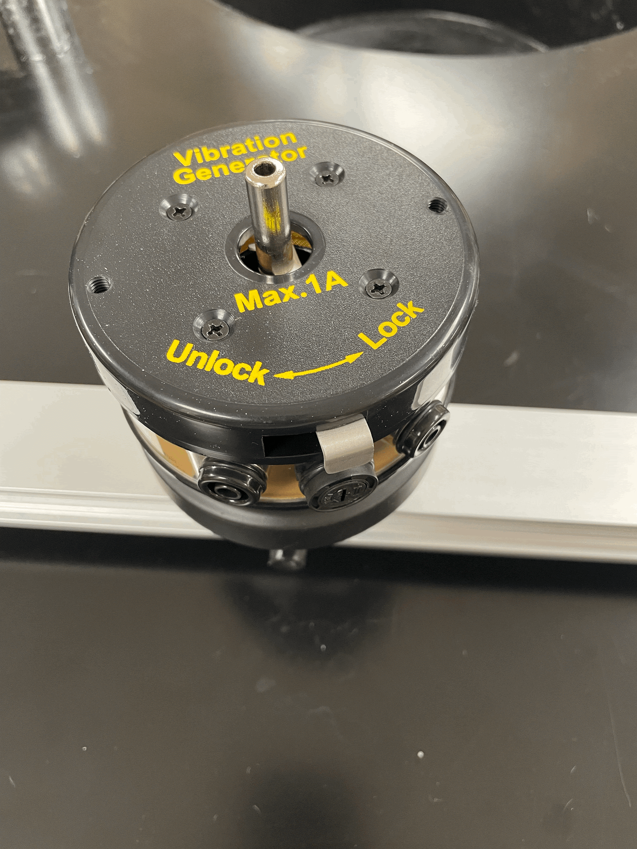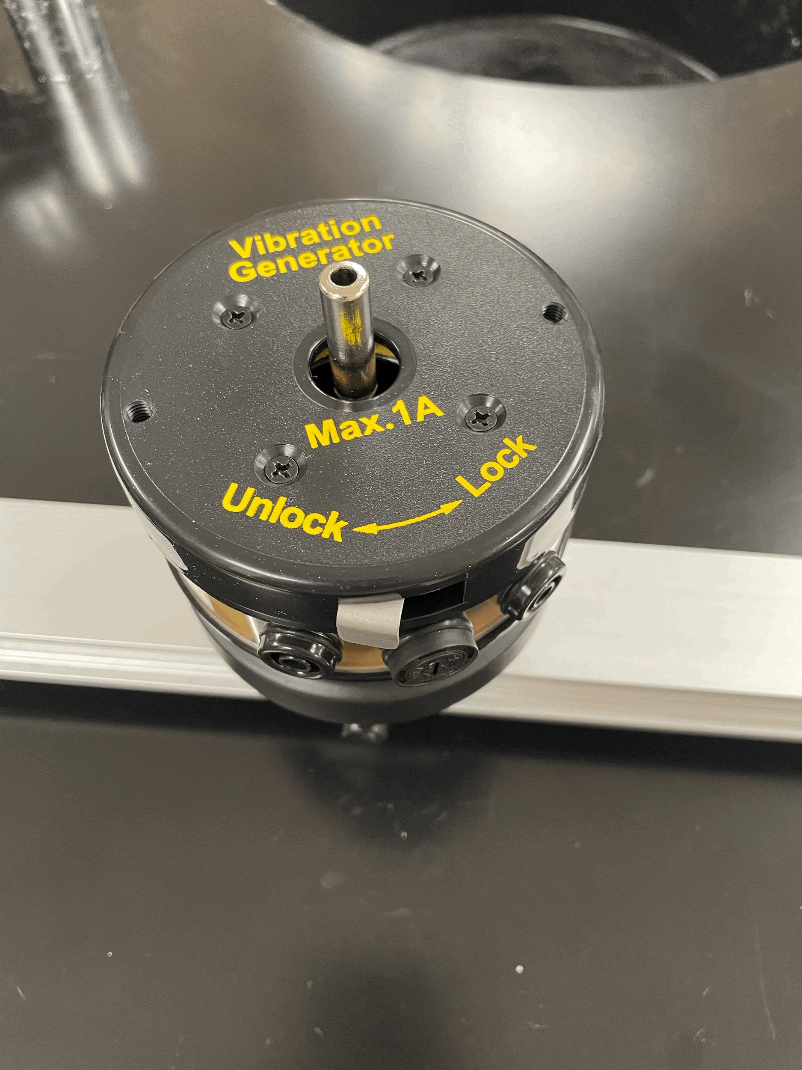

The images above show the vibration generator. This is a very fragile component and should be handled with care. Always ensure that the signal generator is turned OFF when connecting to or disconnecting from the vibration generator. When inserting each component into the metal piece at the top of the vibration generator, ensure that the grey metal tab is switched to “Lock” (pictured left). Applying too much pressure when it is unlocked will damage the vibration generator. Remember to switch it to “unlock” (pictured right) before turning on the signal generator. Again, failure to do so will damage the vibration generator.

Ensuring that the signal generator is off by checking the switch on the back, connect the red and black electrical cords to the vibration generator. Note: it DOES NOT matter which color cord goes where (AC current). Your setup should look as follows:

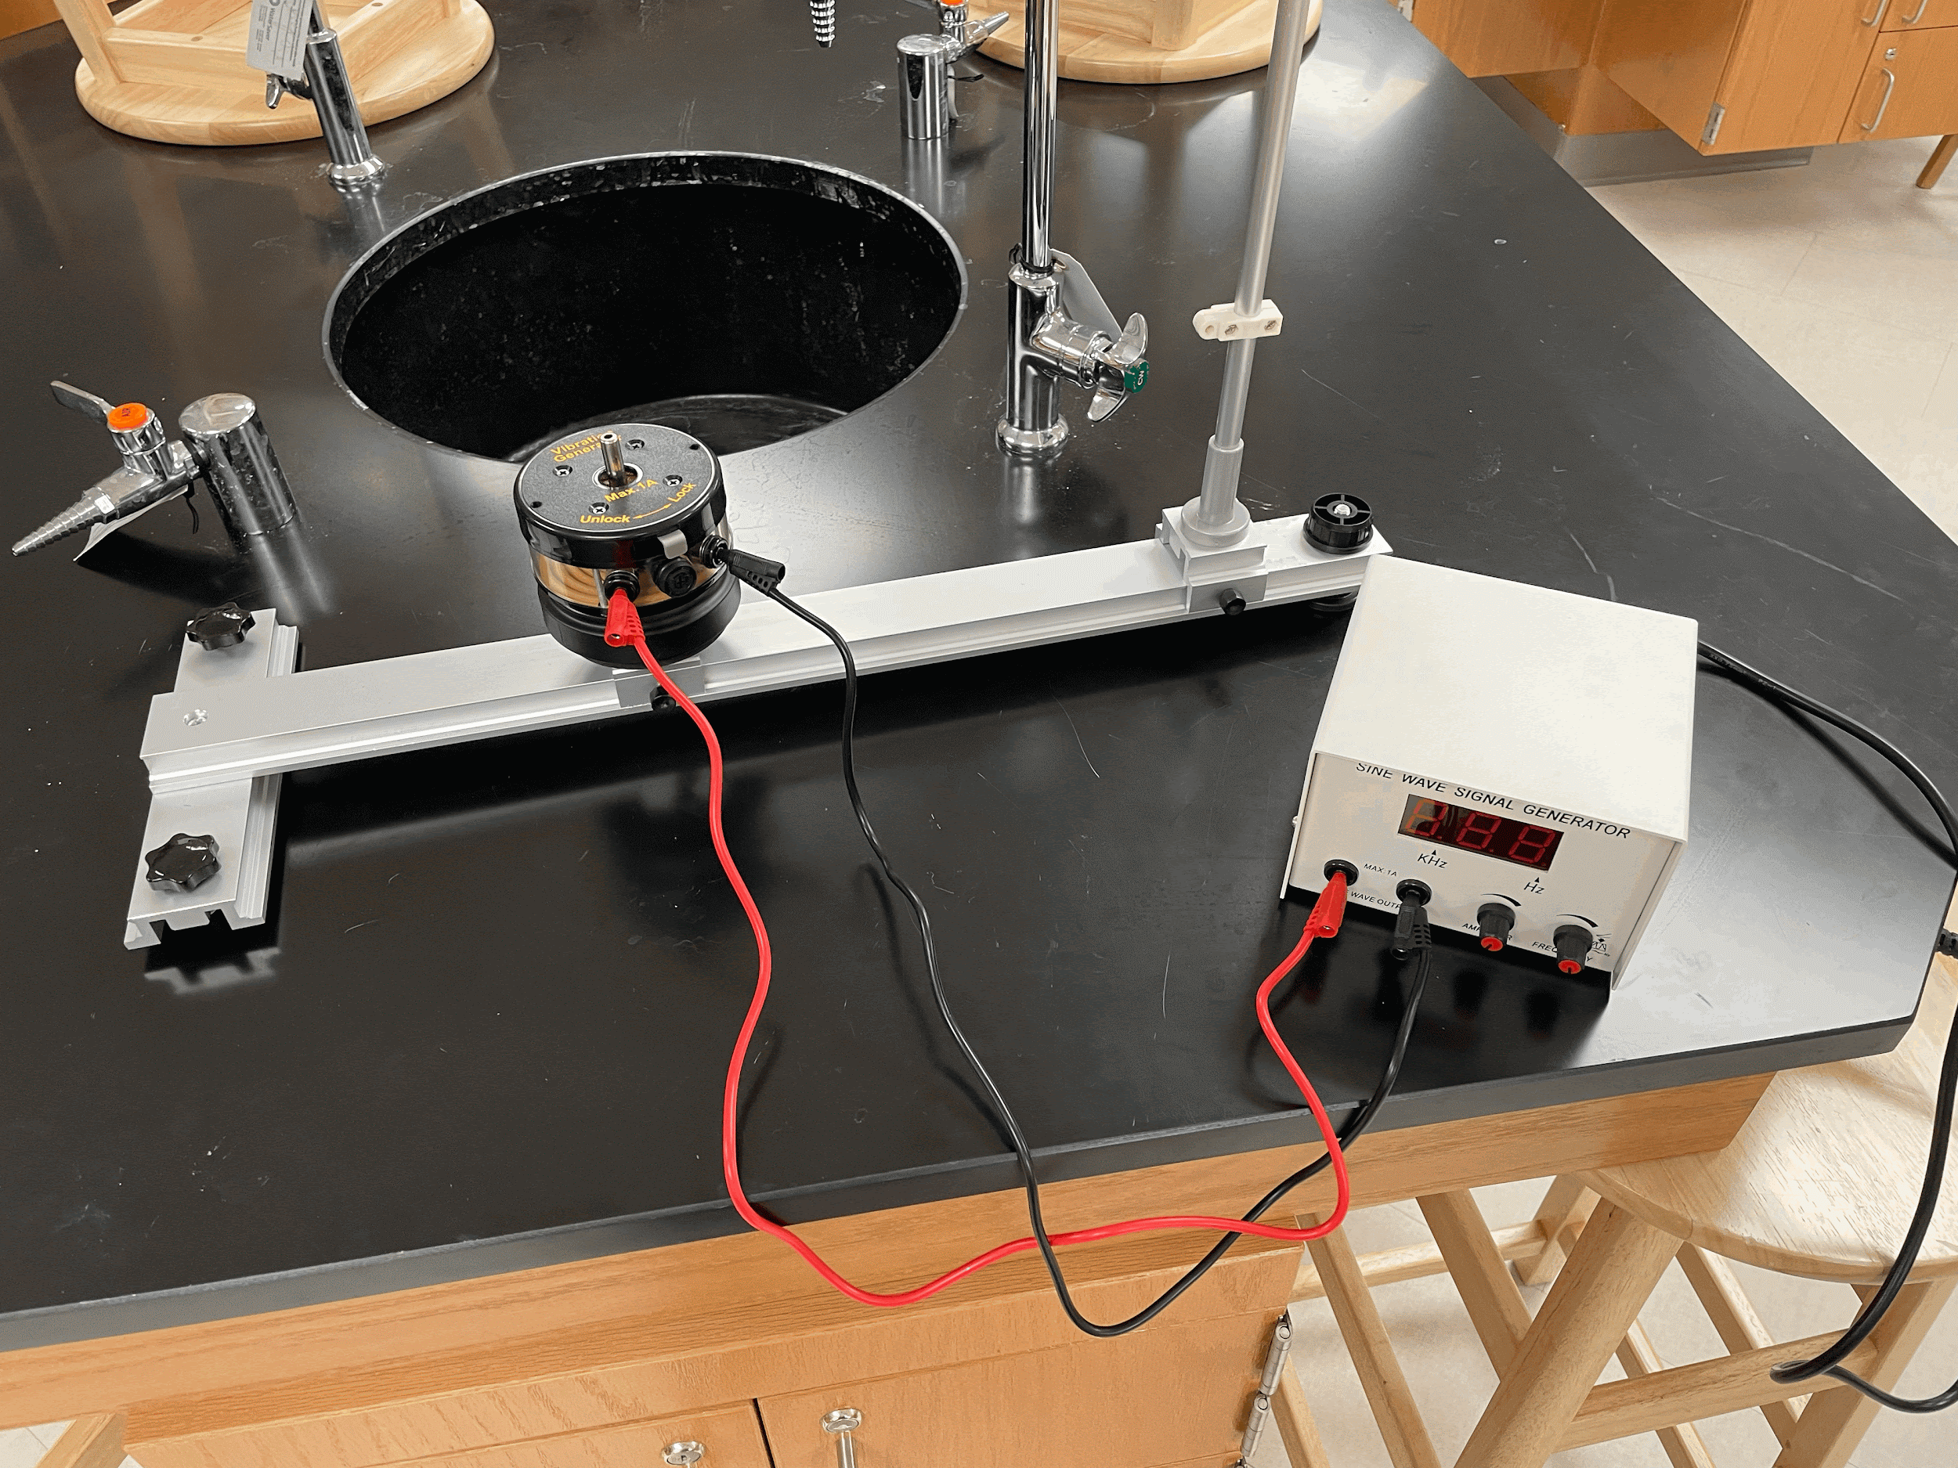

**EVERY TIME you are about to turn the signal generator on, make sure of these two things first:**

1. **The vibration generator is in the “unlocked” position**
2. **The “AMPLIFIER” knob (left knob) is turned all the way down (fully counterclockwise).**

Throughout this experiment you will be connecting different components to the vibration generator shaft and sweeping different frequencies and amplitudes to find different things. The “FREQUENCY” knob adjusts the output frequency. It will automatically default to 30 Hz when it is turned on. Pressing the knob will switch from “Hz” range to “kHz” range, as indicated by the lights on the screen. As you are sweeping frequencies, you may need to increase and decrease the amplitude to get the correct observations. Sometimes you will be able to hear when a frequency is of interest, and adjustment of the “AMPLIFIER” knob will allow you to observe the behavior at that frequency. Don’t forget to make sure that the knob is turned all the way down before turning the signal generator on the next time.

1. Wire Hoop

Position the vibration generator near the center of the base rail, and tighten the thumbscrew to secure it in place. Ensuring that the vibration generator is in the “locked” position, insert the wire hoop into the vibration generator using the banana plug at the bottom (pictured below). Gently holding the generator shaft while inserting each component (as shown) can further help to reduce stress on the system.

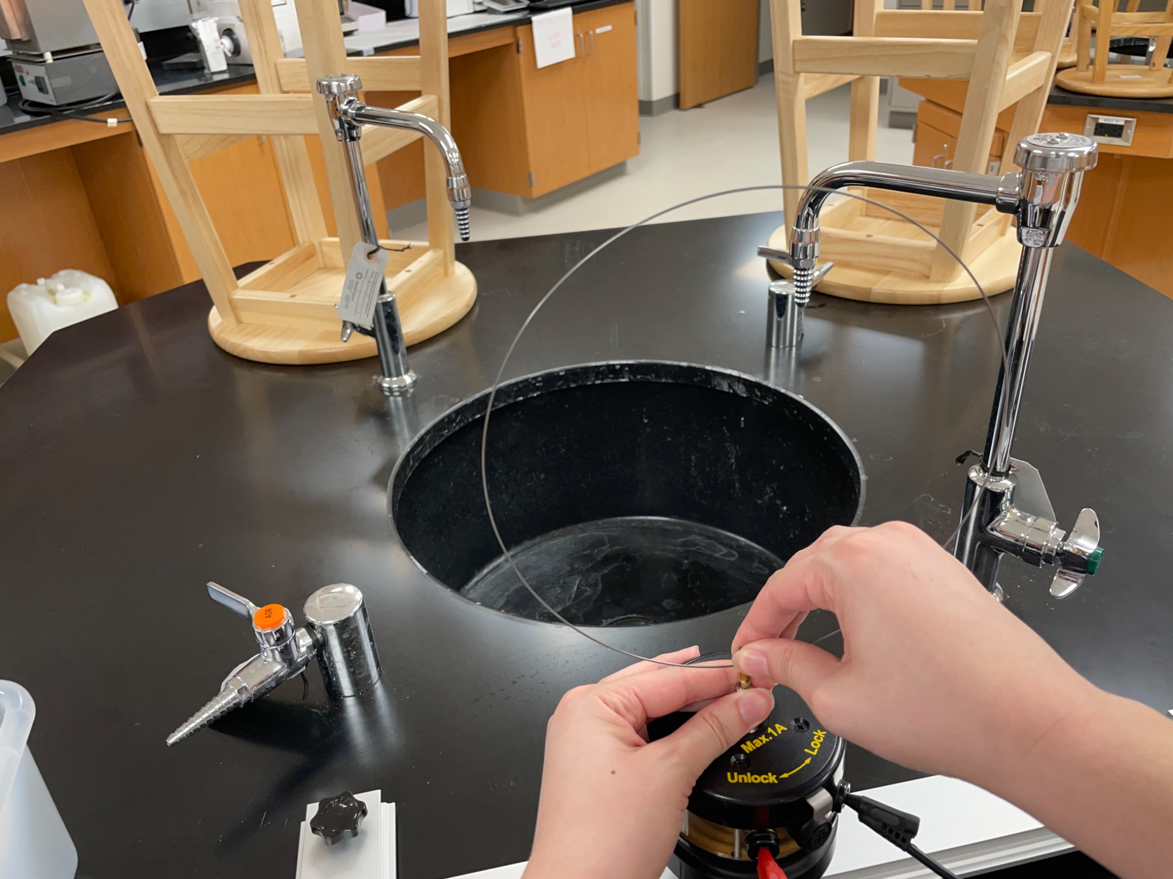

—---- what to do —----------

1. Helical Spring

Position the vibration generator directly next to the vertical support rod by loosening and tightening the thumb screw. Ensuring that the vibration generator is in the “locked” position and gently holding the generator shaft, insert the helical spring into the vibration generator using the banana plug at the bottom (pictured below). Take the other end of the spring and insert it through the hole at the top of the vertical support rod. The height of the rod can be changed by lifting the grey lever to unlock it and moving the top of the support rod up or down. Some of these components are plastic so be gentle when changing the height.

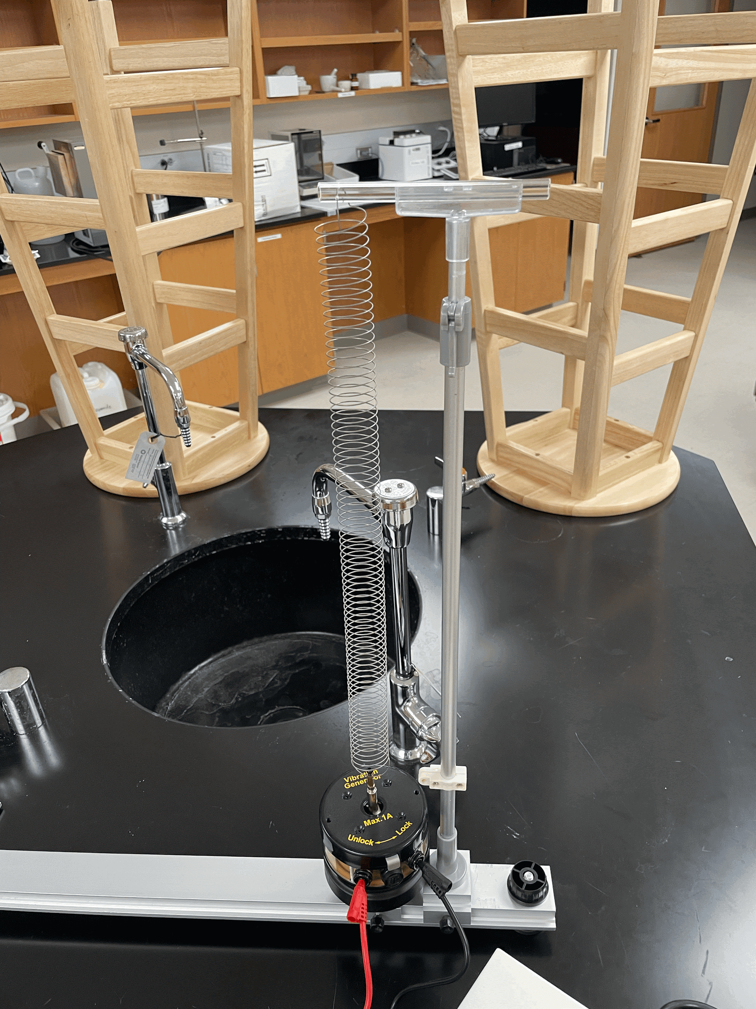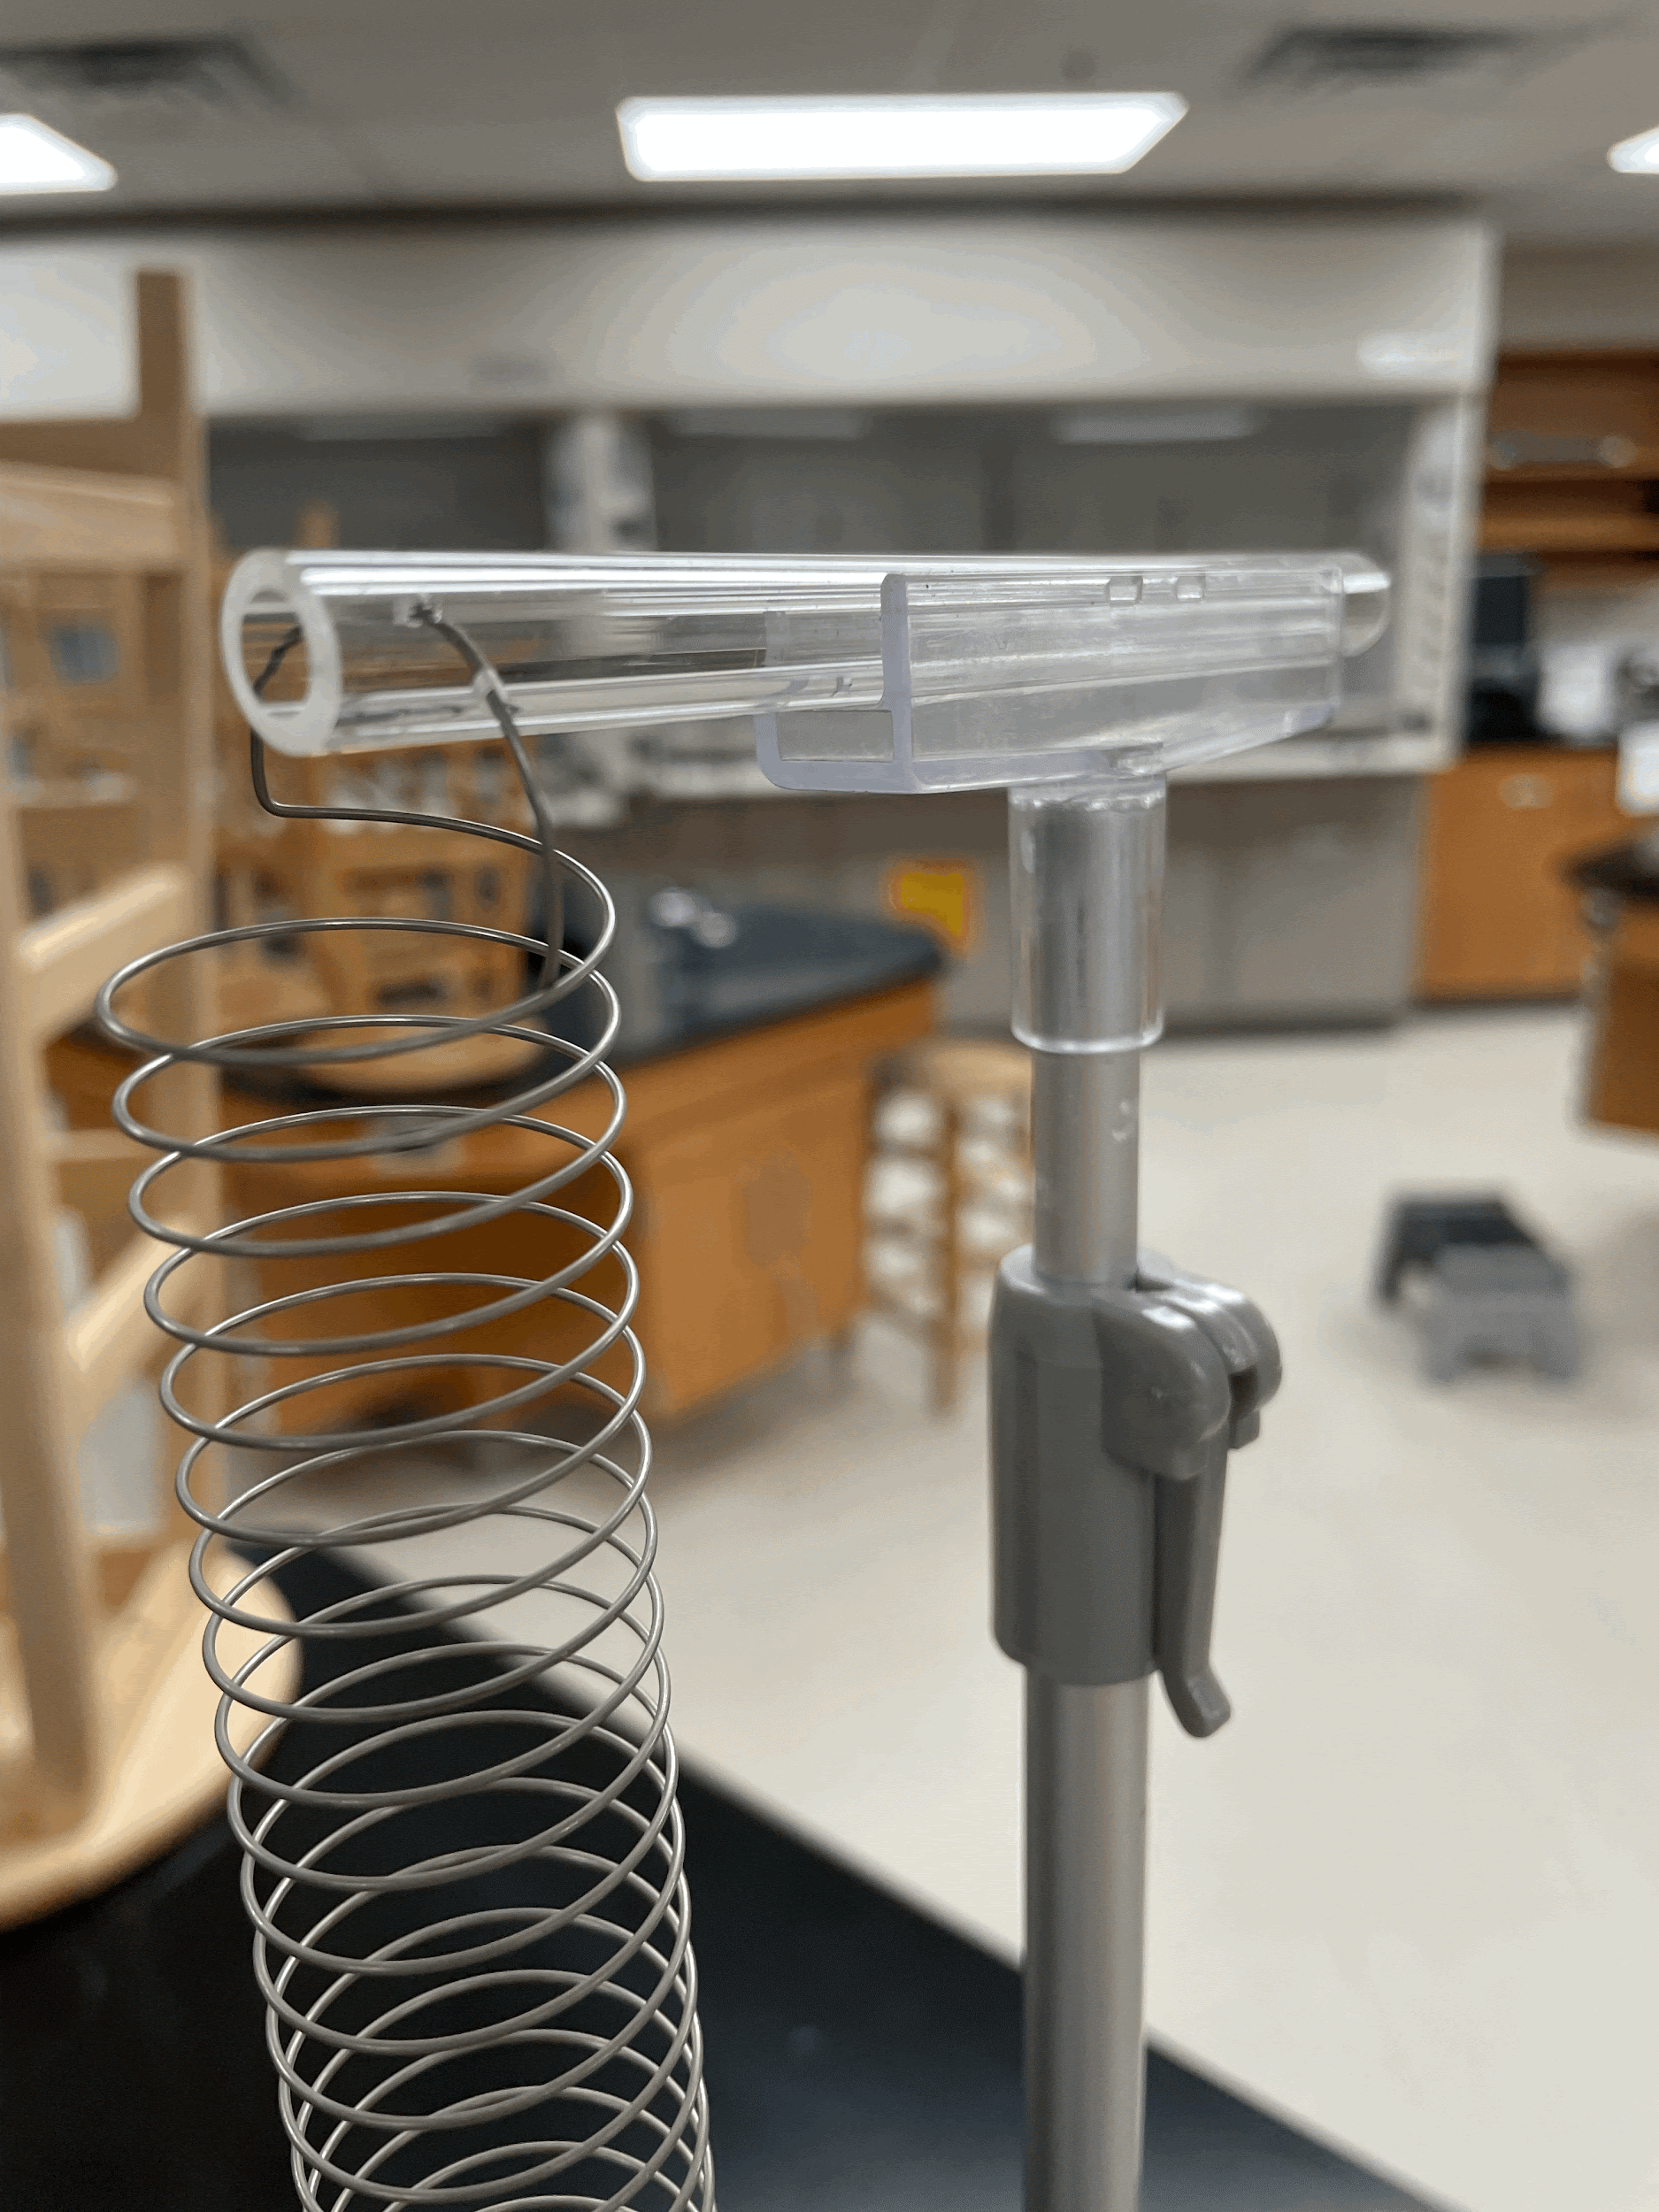

1. Effect of boundary conditions, vary length

#### **Analysis Questions:**